Contemplations on a Krsna book.
(rev. 29 July 2007)

Hanumatpresaka Swami
Anjana Suta Academy
www.JayaRama.US

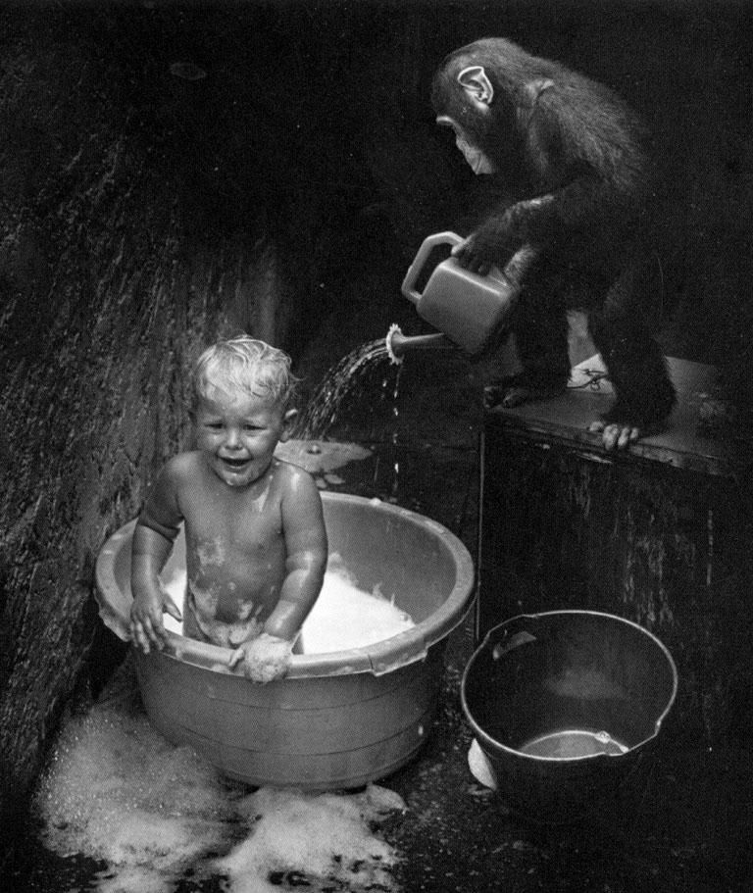

PREFACE
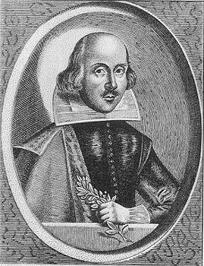
A smallish tract of literature,
An essential little book,
A compound piece of poetry,
Some prose to walk your look.

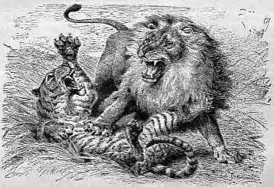
Don’t bite or scratch, or growl or kick.
Grab your coat we must exit quick.

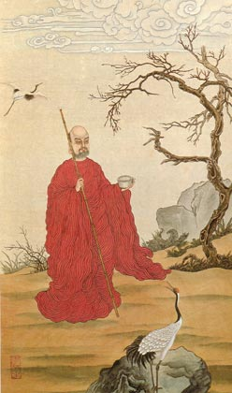

Got some cheese or a cracker box?
Got some twine or a cotton sock?
A book-bag, a blanket, a bucket and beads,
These will satisfy all your spiritual needs.

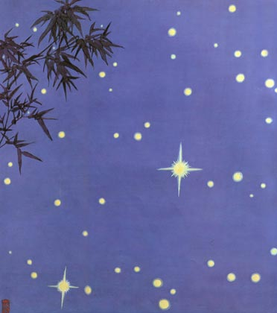

Escaping our karma we stride down the road.
It’s dusk in the country, the gremlin’s abode.
Smells of the evening, kitchen fires, children’s mad glee,
None of this frivolity for me nor for thee.

Long is the walk on the tall mountain’s stones,
‘till the village below us is titterin’ and glown’
We sit in the cottage on the green mountain dell,
A place where the faerys always will dwell.
And now our own fire we strike in the hearth,
And begin to read storys of valor and mirth.
The book is a drowsy-time tale of long far ago,
A place where your mind this evening should go.

DEDICATION
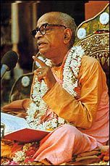
Let us dedicate these words to the Superior Master amongst transcendental monastic leaders, His Divine Grace A. C. Bhaktivedanta Swami, Srila Prabhupda, author of the book KRSNA: The Supreme Personality of Godhead. May our words illuminate the path of both the reader and this writer in their journey to his lotus feet.

INTRODUCTION
With this at heart a natural thought: Where do his lotus feet reside?
Where will we stand if we wish to stay beside his natural stride?

Our humble answer is that they always stand,
In the transcendental land of Vrndaban.

To see this read his Chinese book of art,
Light of the Bhagavata which shows by parts,

A mystical world that delights the heart,
Of even the greatest T’ang poets in their courtly arts

A place to which we can maybe even climb.
Enlivened even as we tread this world of plastic limes.

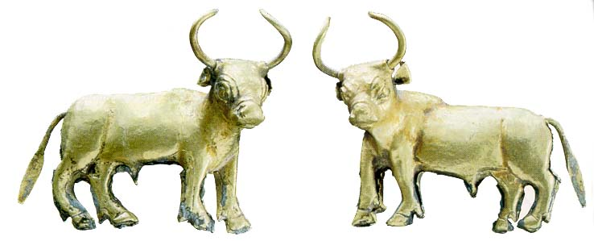
VISION of VRNDAVAN
Radharani loves Krsna. Whatever can She do?
She’s only seven. All these feelings are quite new!
She discusses them with Lalita,
Who is eight and very wise,
And with Visakha and the others,
When they are working side-by-side.

You can live within the matter world,
Or you can now sail amongst the stars,
Or you can seek amongst them Vrindabon
Transversed in bullock cars.

Warning!
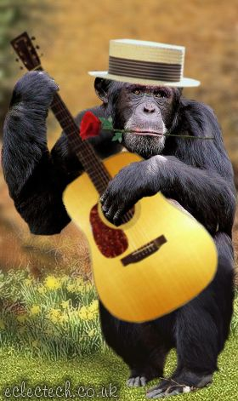

Turn back now and put down this book, If you ever have any hope to ever again relish any mundane gook!
CHAPTER ONE
Monkey and Piggy, poached pearly pink potatoes,
In their percolator pot.
Then brushed with buttered pepper,
The conclusion that they got,
Then passed to Uncle Gismo,
The whole concocted stew,
Because UG was a scientist,
And knew just what to do.

Ж

As you may have already heard Monkey/Piggy sold their pretzel cart, Ol’ Betsy, to buy a little one-masted sail-boat from an odd dude who was just coming out of an evening prayer meeting at the Hare Krsna’s Witnesses Kingdom Hall on the sea-coast of Northern California.
“O.K.”, said Monkey, “here’s a book, How to Sail a Boat, let’s go!”
And without much more planning they said, “Jaya Rama”, (put on a bucket of potatoes) and headed off into the Pacific sunset.
Well, it was only a short time of self-inflicted nausea and sailing in circles until ---



--- Plop! Boom! Right down from out of the sky came Uncle Gismo crashing into the ocean with his space-ship, Bucket of Junk. As they pulled him out of the water and covered him with a blanket he looked on sadly as the BOJ fragmented in the water and dissolved back into Warp World Nine.

“Oh! My!”

Well since then U.G. was forced to travel with Monkey/Piggy, often to the mutual consternation of all.

Their first job, as you may have already heard, was to get out of the realm of gross matter, and that required just strict mechanical, though transcendental, tricks starting with Transiting the Sun at 12:01 noon by almost ramming full sail into the Tourist Promenade at Joe’s Island.
It was, although hair-raising, a success and the SM (Sriman Vahan (their little sail-boat)) rose from the sea at the last second and made it past the church steeple with the help of a timely hatchet whack from Monkey and was finally running out in the space between the stars.

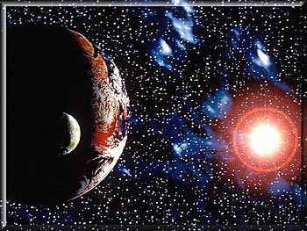
It is here that we have taken up this current narrative, and described the potato porridge that passed into Uncle Gismo’s pot.

Monkey: “What will you do with the poached potatoes, Uncle Gismo?”
UG: “Sanctify them before Sriman Narayana, Simian. By eating the remnants of that sacrifice our bodies will become wholly efficient in carrying out our mission.”

Monkey/Piggy: “What is our mission?”

LIFE’S ULTIMATE GOAL
UG said, “Oh! ! ! It is very disturbing, very disturbing, Sri Radhika, the daughter of the good cowherd King, Maharaja Vrsabanu, has been kidnapped!”

“Oh, goodness!”, said M/P

“Yes”, said UG, “by the evil pirate, Ravana. He’s kidnapped her and is trying to scare her into baking cookies for him and his evil cohorts. But no matter how much she is scared she still refuses to make cookies for anyone except Nandulal, Krsna!”

“Who is Nandulal”, they queeried?

UG looked seriously and pulled out a book from the bookshelf.
Monkey jumped. He’d never noticed a bookshelf in the SM’s cabin before.

Piggy said in a low voice, “It’s an Every Fresh Bookshelf. If you pull one book out and finish it, when you put it back, you’ll always find at least three more new books.”

Monkey: “Whoof!”.

“I had to save the most important things first when the SM crashed”, added UG.

The book’s title was Night of the Bhagavatam.

“Light of the Bhagavatam”, interjected UG, “but this is an edition from my world, Warp World Nine. It’s just like this world only different.

Monkey: “Aacha”.

UG opened the LoB to Plate Twenty-Two and read the Text and Srila Prabhupada’s elucidation.

M/P nodded. Now they had a little idea who was Lord Krsna.

Ж
Our mission is to (1) find Sri Radhika and (2) reassure Her that help is on the way and (3) take the news of Her location back to Krsna (Nanda-gopal) so He and the cowherd boys can come and rescue Her.

“1, 2, 3”, said M/P.
“Today!”, said UG.

CHAPTER TWO
A Brief Repair Stop
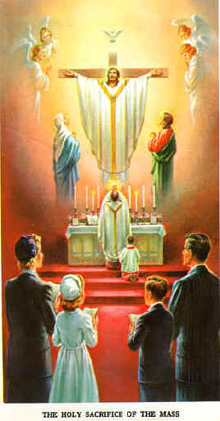

U. G. said that they were on their way to Nila-cala, the Blue hill, but they had to stop-off at the first port they could find to do some quick fixing for the ABC for things that had become a little disarrayed during the Transit.

While this was being done Monkey walked around the port, which was a small place, mostly full of other boats also in transit.

He found that the wharf was having lunch.
People entered the Chapel and sat in a bunch.
The priest was from a Catholic nation,
But his handshake lacked all determination.
Still, God is so eager to give us His word,
That even there it was being heard.

“John told the people: Watch-out! Beware! Look-out!
This is our last meeting and then to rout.
Chains and tests from the Emperor’s police,
But always assurance for he who believes.”

ALWAYS CHANT 16-GOOD ROSARIES DAILY

Monkey was hungry because there were only potatoes on the ABC,
So he prayed to God for permission,
And then ate a box of little Hersey blocks,
It cleaned his gloves & tie & socks.
Now he could stroll his stroll,
And walk his walk,
Through the lanes of the of the Transit Mall,
Where sales where made from Whiskey Stalls.

Beach Brother’s Dickeys
And Dickey Brother’s Briefs.

It was all pretty booring and the only thing impressive was the news in the Newspapers about all the natural and political catastrophies that were occurring because of the Kidnapping of Sri Radhika. Monkey walked back to the ABC with more motivation and also a little scared to do something quick to help UG find Sri Radhika.

CHAPTER THREE
Three Minutes with a Genius


When he got back to the pier Monkey saw Piggy bustling around loading the last of different Puja paraphernalia, applying new rope and getting ready to cast-off-lines. UG was sitting side-by-side in the Cockpit of the SV with an effulgent looking man with a beard and a turban.
Piggy yelled, “Three minutes to Cast-off”, and Monkey jumped on board. The man with the turban then asked UG, “Please, then a quick answer to this question -- Why does religion sometimes divide peoples rather than unite them?”

sri gismo uvaca
(the blessed gismo said)
First let us make a definition of God. Maybe it has some universality and will be useful to a practical number or people. In the Hare Krishna, tradition, Bhagavad-gita 10.8, God, Bhagavan, Krsna, is defined as the cause of all causes, the source from which everything emanates. In Christian tradition we also find that the Apostle’s Creed, the Nicene Creed or the Credo as it is called by various groups says the same thing: We believe in one God, Father Almighty, maker of heaven and earth, by whom all things were created....

After giving this definition of our comprehension of God then let us also define what we mean by religion. Religion means to re-ligare, re-link, with God. We all have our eternal relationship with Him, just as sons all have an eternal relation with their father. Sometimes for various reasons that becomes covered by temporary designations such as banker, student, bus passenger et al, we wander away from home, but behind all of these is our eternal relation and active drama with our Eternal Father.

Again, in the Hare Krishna religion, Srila A. C. Bhaktivedanta Swami, Prabhupada, the Founder Acharya of the International Society for Krishna Consciousness, explains that we are followers, and executing our religious activities, under the shelter of the 16th century saint, Rupa Goswami. In his turn, through Sri Krishna Caitanya, Madhvacharya and eventually Sri Krsna Himself., Rupa Goswami and his associates give general principles and practical details of how to revive our original relation of pure love for God. Rupa Goswami mentions as his first principal that one who wants to approach God, must find a self realized, authorized representative of God, Acharya in Sanskrit language, and take shelter of him. This means that one should hear patiently from him to get a proper understanding of this material world and the process for escaping from it and going back home, back to Godhead.

By hearing we become free from lust and ignorance and regularly more fixed in wisdom and honesty. Then with clear understanding we take formal vows such as Baptism or Diksa, again in Sanskrit. At this time we are formally matriculated into a religion, a school, for becoming purified to return to God.

Rupa Goswami explains that there are universally three levels of religious people. In the most basic level we call upon the Name of the Lord, but actually our real faith and determination is in matter and satisfying our lust. One man approaches God for beautiful wives and domination over his enemies and another approaches for ice-cream and fine poetry, but in the lowest level we are following some type of religious principles for our own egoistic satisfaction.

This then is where we find violence amongst different religious groups, amongst those who follow, but not strictly, without proper guidance or authority and for their materialistic advantage. We have heard Mahatma Gandhi being quoted as saying that there is enough for everyman’s needs, but not enough for everyman’s greeds.

On the second level, maybe after being bumped and bruised sufficiently by the natural reactions of his own misdeeds, the religious man takes shelter of an Acharya, such as Our Lord Jesus Christ, the Prophet Mohammad, may his name be blessed, or Sri Krsna Himself in the Bhagavad Gita, or others. In this stage one has taken diksa from a bona fide Acharya and is engaged by him in practical activities of devotional service with his present mind, words and body. In this state he still has egoistic desires but they are under control and diminishing. Between such second class fellows from different religions there can be useful, even absolutely necessary, co-operation in the service of the Lord and mutual impetuous for advancing. They have their egoistic vanity for their own religion, but it is under control and by using intelligence and establishing norms they can associate and work together quite practically.

In the first class position, the practicioner of his religion has achieved the goal. He is very advanced in undeviating service to God and his heart is completely devoid of the propensity to criticize others. On this level there is spontaneous appreciation and co-operation between Saints from different lines. Such interfaith dialog is perfectly useful, blissful, and we should be very eager to obtain it.

Thus, to summarize, if we really follow the path dictated by our Acharya, Prophet, Messiah, then, it will lead us to greater and greater integration with those in other religions.

With these words let us thank you for this meeting and our sincere hopes that we meet again and that you will push us to always stay on our path.

“Excellent, excellent”, said the effulgent man with the turban as he shook UG’s hands and stepped off the SV. Piggy cast-off-lines and pushed the SV into the outgoing tide of the bay.

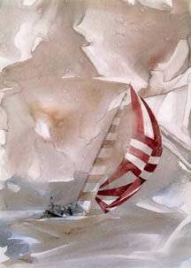
Uncle Gismo was in the cockpit of the SV. They had to move pretty fast because the out-going tide would not last for too long. Monkey took up one of the sweeps, long oars, and Piggy the other. They began rowing very hard as Uncle Gismo yelled at them to “Put their backs into it”. Actually, only within a few minutes they caught the tide and the wind came up and the SV began to move swiftly. UG began yelling more orders about rigging the sails and Monkey was running up and down the masts, spreading sails, tying, un-tying, and adjusting ropes. The wind got stronger and the SV literally began to fly. It was a great act of seamanship to catch the wind and keep the SV from capsizing. It pulled harder and harder and harder and then... it was coming completely out of the water. They reached the rim of the Transit Bay World and once again were back out in outer-space headed for Niladri in their search after Radharani.
For the first few hours Monkey just sat up in the Crow’s Nest.

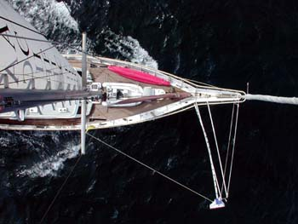
Down below Piggy was moving about industriously in his sailor’s suit swabbing the deck, putting things in their place etc, etc.
After some time Monkey wanted to read a book and he swung down into the SV’s cabin and looked for the Night of the Bhagavata (Light of the Bhagavata bellowed UG) in the Everfresh Book Case. But every time he would try to pull it out, another little pamphlet, The Medical Miracle of Mangala-arati, would fall out and land on the floor in front of him. He tried this again and again and eventually was pulling on ... Light of the Bhagavata .... with both hands and his feet while barking and howling, but it was no use. The Everfresh Book Case was more determined than he. So, adjusting his scarf, Monkey picked up The Medical Miracle of Mangala-arati and haughtily addressing the EFB declaring, “Actually I really wanted to read this first anyway!”

Back up in the Crow’s Nest the sun was shinning, the wind was blowing, the SV was plowing swiftly through the waves and Monkey began to read.

Ж

The Medical Miracle of Mangala-arati
by Prof. Guy Gismo
After the rasa dance was over, the night (the night of Brahma a very long period, as mentioned in the Bhagavad-gita) turned into the brahma-muhurta. The brahma-muhurta takes place about one and a half hours before sunrise. It is recommended that one should rise from bed at that time and, after finishing daily ablutions, take to spiritual activities by performing mangala-arati and chanting the Hare Krsna mantra. This period is very convenient for the execution of spiritual activities. When that auspicious moment arrived, Krsna asked the gopis to leave. Although His beloveds were not willing to quit His company, they were very obedient to Him. As soon as Krsna asked them to go home, they immediately left and returned home.
Krsna book 33-chapter, BBT

Lord Krsna used to lie down with His sixteen thousand wives, but He would also rise from bed very early in the morning, three hours before sunrise. By nature’s arrangement the crowing of the cocks warns of the brahma-muhurta hour. There is no need of alarm clocks: as soon as the cocks crow early in the morning, it is to be understood that it is time to rise from bed. Hearing that sound, Krsna would get up from bed, but His rising early was not very much to the liking of His wives. The wives of Krsna were so much attached to Him that they would lie in bed embracing Him, and as soon as the cocks crowed, Krsna’s wives would be very sorry and would immediately condemn the crowing.
In the garden within the compound of each palace there were parijata flowers. Parijata is not an artificial flower. We remember that Krsna brought the parijata trees from heaven and implanted them in all His palaces. Early in the morning, a mild breeze would carry the aroma of the parijata flower, and Krsna would smell it just after rising from bed. Due to this aroma, the honeybees would begin their humming vibration, and the birds also would begin their sweet chirping sounds. All together it would sound like the singing of professional chanters engaged in offering prayers to Krsna. Although Srimati Rukminidevi, the first queen of Lord Krsna, knew that brahma-muhurta is the most auspicious time in the entire day, she would feel disgusted at the appearance of brahma-muhurta because she was not very happy to have Krsna leave her side in bed. Despite Srimati Rukminidevi’s disgust, Lord Krsna would immediately get up from bed exactly on the appearance of brahma-muhurta. An ideal householder should learn from the behavior of Lord Krsna how to rise early in the morning, however comfortably he may be lying in bed embraced by his wife.
After rising from bed, Lord Krsna would wash His mouth, hands and feet and would immediately sit down and meditate on Himself. This does not mean, however, that we should also sit down and meditate on ourselves. We have to meditate upon Krsna, Radha-Krsna. That is real meditation. Krsna is Krsna Himself; therefore He was teaching us that brahma-muhurta should be utilized for meditation on Radha-Krsna. By such meditation Krsna would feel very much satisfied, and similarly we will also feel transcendentally pleased and satisfied if we utilize the brahma-muhurta period to meditate on Radha and Krsna and if we think of how Srimati Rukminidevi and Krsna acted as ideal householders to teach the whole human society to rise early in the morning and immediately engage in Krsna consciousness. There is no difference between meditating on the eternal forms of Radha-Krsna and chanting the maha-mantra, Hare Krsna.
Krsna book 70-chapter

“So that’s why roosters never have any money,” thought Monkey, “they’ve been cursed by Laksmi-devi!”

Devotional service means transcendental activities. On the transcendental platform there is no contamination by the three modes of material nature. This is called visuddha-sattva, the platform of pure goodness, or goodness free from contamination by the qualities of passion and ignorance. In this Krsna consciousness movement we require everyone to rise early in the morning, by four A.M.,and attend mangala-arati, or morning worship, then read Srimad Bhagavatam, perform kirtana, and so forth. Thus we hold continuous activities in devotional service twenty-four hours daily. This is called sato vrtti, or following in the footsteps of the previous acaryas who expertly filled every moment of time with Krsna conscious activities.
Nectar of Instruction 3-text, BBT

The book continued.

Before the passion of business, school, work, starts, after breakfast, and after the stoopidity of ignorance is finished, the day is in the mode of goodness. Let us say from 2-10AM is in the mode of goodness, 10AM-6PM passion, work, and then the Happy Hour (for the fools) starts at 6PM, with half-priced liquor, and continues until 2AM.

2AM-10AM
10AM-6PM
6PM-2AM

If you get up early and work hard during the mode of goodness, japa, mangala-arati, illuminated studies, then your perspective is fixed. You start your day with your mind and senses all in the right direction and then it actually become child’s play, a game not work.

Look at the ordinary Joe. He comes home from work. Sits for a few minutes. Talks with his wife and kids. Has a bath, his dinner and then takes his kids to the Mall for shopping. He doesn’t become inactive but now it is play not work. Same thing for the brahmana. He works hard from 2AM until 10AM. He works hard controlling his mind with his meditation rosary, singing select hymns, dancing vigorously and studying books. Then after breakfast, teaching, making money, manual labor, it’s all fun, spontaneous.
Chose how you want to work.
You can drink nectar with the gods,
Or you can drink beer with the dogs.

Monkey didn’t have anything against dogs, but it did seem nicer to drink nectar. He continued.

At mangala-arati we go before the altar of Radha-Govinda (big or small) and sing and dance - Hari bol! Hari bol!

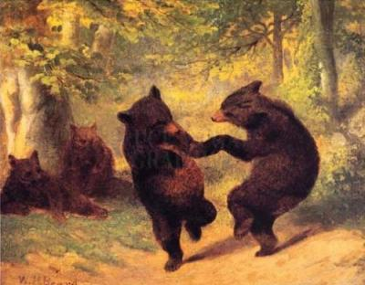
Even if you don’t feel like it. Put your hands over your head and jump-up-and-down and sing the song, and dance the dance. You will feel better. For every technique in the astanga, hatha-yoga, system there is a corresponding technique in the bhakti-yoga system.

The blood circulates in veins pumped by the heart. The lymphatic system also has veins but no pump. This system is like the sewage lines in your house and the city. All the garbage and trash from the body is carried out by the lymphatic system. So when you jump up and down and roar and chant it forces the circulation through the lymphatic system.

Veda-vyasa Das: You know, UG, after that conversation we had where you said that the only reason for not coming to mangala-arati was an inability to crawl and I said that I sometimes slept later because I had so many management responsibilities and so forth, I thought about what you said, and I came to the conclusion that it’s a fact, that there has not been one time when I made the decision to get up for mangala-arati that I later regretted it.

Get up. Get rich. Put rocks in your bed. Marry an ugly girl. Buy a rooster, but come to mangala-arati.

Of course, you may ask, “What do we do when we get there? Now that we know the Medical Meaning of mangala arati, what is the Deep Significance of mangala arati?”

A good question, but maybe best we discuss that later, I think that now if you look your Mother is calling you and you’d best attend to her desires.

Monkey put the booklet down and looked down at the deck. His Mother wasn’t calling him but UG was waving his arms and yelling at him furiously trying to say something above the wind. So, Monkey put the pamphlet in his shorts and swung on down to see what had got UG so hot under the collar.

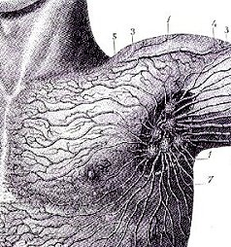
Some Lymphatic Veins

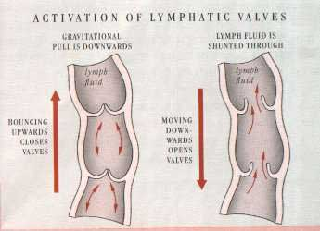
Valves Only Allow One-way Flow - Jump!

CHAPTER FOUR
The Night of Brahma
Sometimes Monkey would have to run here and there to adjust the sails and lines when the winds changed, but often there were long hours of leisure. Sometimes it was day. Sometimes it was night. Monkey couldn’t quite figure it out. Piggy explained that because they were on the road to Nilacala time and space all had taken on a nature full of significance their purification. Monkey didn’t mind that --- pure, purer, purest!
He wanted to read the Night of the Bhagavata (L I G H T of the Bhagavata!), but Piggy said that he had to finish his correspondence course for the Bhagavad Gita first. He growled, whined and complained, but Piggy was determined, and Monkey couldn’t do anything without Piggy’s approval, so he set to work.
He had already finished the first 9-chapters so now he started on the last 9-chapters. He just read them all with Srila Prabhupada’s purports and then read the sample tests from his school the VIHE. It meant Vrndavana Institute for Higher Education.

ABC - Simian Summaries
Chapter Ten, Bhagavad-gita As It Is, BBT
Actually Chapter Ten is a continuation of Chapter Nine. In the beginning there is a little discussion of how Krsna cannot be even known by the Demi-gods, but He tells of some of His glories: Honesty, intelligence, fame, fine speech, they all come from Him. Then He gives a summary of His whole Bhagavad-gita in just four verses, 10.8-11.
What is that?
Arjuna really thanks him and says that He is God and that even Narada Muni says that He is. Then Arjuna says, “sarvam etad rtam manye…”, I totally accept as truth all that you have said. But after that for our benefit he asks Krsna to explain a lot of real obvious manifestations of God that an ordinary person can appreciate, like the taste of water, the light of the Sun, the ocean amongst bodys of water, the wind among purifiers, the ability in man.
(Monkey laughed and looked around him -- saw the ocean waves tossed for all eternity beneath the sun by the powerful wind and looked down at UG below at the tiller. He laughed for a long time, “And some people say that they are God, we are God, we are all God!”. He laughed for a long, long time then placed his pencil to his paper and finished his summary)
After He gives so many vibhuti mat sattvas Krsna finishes by saying, “But what is the use Arjuna of all these detailed explanations. With but a single spark of my splendor I pervades and maintain the entire universe (ekamsena sthito jagat). In Chapter Eleven Arjuna will ask to see that amsa, spark.

At this point Digital Rat 108 dropped onto Monkey’s head. Monkey flailed in panic and then realized it was 108 and that he had a message from the deck from Piggy. Monkey looked down and Piggy gave a wave to him and continued with his work.

Monkey looked at the message. It was an article for book for Professor Bandyopadhyay that Hanumat Swami had written some time. Monkey read it, after all, who in the name of time are these people, HpSwami, Professor Samaresh?!

Ж

Bio Dr. Bandyopadhyay (6 Jun '07)

EVEN A CAT CAN LOOK AT A KING
Biographical Remenisciences of Professor Samaresh Bandyopadhyay
by H. H. Hanumapresaka Swami (Prof. Huber Hutchin Robinson)

We were riding on one of the ubiquitous little red buses that transport people around Calcutta in the murderous tropical heat. A rather cultured looking gentlemen sat down next to us and said, "I noticed you were reading some texts from Sanskrita. Do you know Sanskrit? I also have interest in Sanskita." Thus began my association with this great soul, Professor Samaresh Bandyopahyay, in Calutta, West Bengal, in 1996. Of course, later I was to learn that this gentleman who "also had an interest in Sanskrita" was former Head of the Department of Ancient Indian History and Culture at Calcutta University and one of the most distinguished numismaticists of our times. This current remeniscience will be brief so let me just ponder a few things that come to my mind in our years of fortunate association with Professor Bandyopadhyay.

1) Our very first meeting contained several elements that were to become more apparent in the years to come. Many times I found him speaking strongly against history that was produced just by sitting in a library re-hashing the works of others. The Professor, I experienced, was a man who built his professional contribution, and his life, on direct experience, not that he wasn't a very well read and considerate scholar also. But when he entered the bus and saw an odd looking Westerner in the dress of an Indian sannyasis he didn't hesitate to investigate the phenomenon by directly poking his nose into the fellows books and mind.

2) And very fortunate for us it was that this contact came, for we were struggling to do much of the preliminary work for the presentation of the Bhaktivedanta Institute's "Second World Congress for a Synthesis of Science and Religion". Later when he met our Director, Dr. T. D. Sing (H. H. B.S.Damodara Swami) he became one of the pillars of the success of the Congress.
During the production of the Congress, besides high-minded thoughts and lectures, there were also many hours of down to earth physical labor to select paper from Calcutta's medieval print shops which could only be approached by pedal rickshaw in the jostling, sweating crowds. We have had some experience in the practical work of printing books and I discovered that Professor Bandyopadhayay was a practical master of all the stages of production, from selection of paper, type styles, editing, printing, binding and distribution.

During the actual production of the Congress one of the principle speakers was Prof. S. K. Mukherjee, former Head of the West Bengal Science Association and a highly esteemed scientist. During his presentation to a hall of scientists, scholars, cultured ladies and gentlemen of Calcutta and International Delegates, he said, "I have been a scientist for 30-years, and we all know that science does not answer all the questions." I looked around the hall and saw many heads nodding in agreement. "So", he continued, "I suggest that we take up the study of religion, not in a haphazard way, but with the same attention with which we study in science". These comments met with a warm and broad response. After his presentation as I walked him to his seat I asked him, "Do you have much chance to talk like this at other venues?" And he responed that this was probably the first chance in 20-years that he had been able to speak like this. The Congress has have to have had a heavy effect on world history and Dr. Bandyopadyay was definitely one of the pillars of its success.

3) I graduated with a first place prize from the University of California in Psychology and subsequently have worked in the university and academic enviroment for a long time. In the beginning I guess that many of us have this naive idea that the academic world is one full of pure genius and harmonious scholarship. That is there but there is also a God awful amount of politics. Looking at the historical example of personalities such as Emperor Candra Gupta and his prime minister Canakhya Pandita we see that the scholar, intellectual, academic, is the "politician's politician". In his work for ourselves, the Asiatic Society of Calcutta, Calcutta University and many other times, I have seen the Professor switch an entire railroad train of box-cars onto an entirely different line of tracks at full speed with only a few cunningly chosen words. Often I was dumbfounded to see this man whom I know of such academic absorption and character to deal so adroitly for one moment with the intrigue and power that is a part of the modern academic world.
But even though he was aware of these often very frustrating political shenanigans of others, he seemed to never "become his enimies enemy", a quality that I have learned from our preceptor Srila A. C. Bhaktivedanta Swami is one of the real characteristics of a lover of God. He would become irritated with the often low class political dealings of people, which we probably all fall into more or less, but then he would restrain himself, "But that is not worthy of further discussion", and continue with the work, appreciating the good qualities of the same people with all sincerity and pragmatism.

4) Let me conclude with the comment that often we were often generously hosted by the esteemed professor and Mrs. Bandyopadhyay. We had the esteemed opportunity to help as we could in the family affairs of children, brothers and others, and also to see Professor Bandyopadhyay dealing very often with younger scholars and younger people. He had an extraordinary ability to engage them. They were struggling for an interesting and useful topic for a Master's or Doctorate Thesis. He would tell them where to go in Calcutta to make some field investigation and interviews. He would tell them where to take up a shovel and start digging to look for artifacts. He answer their questions about life and death political struggles that joyously empowered them to make their own decision while at the same time offering a few simple guidlines that would doubtless stick in their hearts as support for a whole lifetime.

So, I have to stop here. We have to follow the doctor's advice and not spend too much time in just writing about things. We have been in the broiling depths of Calcutta together. We have been through the great circus of Puja in Calcutta together, the hills of Manipura together and walked with our students on the bank of Krishna's Yamuna together. I can only hope that there will be more pages to these biographies, extending even life after life.
All thanks Professor for your friendship and association and best wishes in the struggles that lie ahead.

Ж
ABC - Simian Summaries (continued)
Chapter Eleven, Bhagavad-gita As It Is, BBT
Monkey would read the BG As It Is when he got a chance. He wanted to always read it, re-read it and so forth and so on. He thought of Satsvarupa Das Goswami and how he always said we should read Srila Prabhupada’s books. So he did. Also he wanted to get a great score on his ABC, Bhakti-sastri test.
Chapter Eleven
Main thing was the phrase, “drastum icchami te rupam”, I want to see that form of yours, the form that you explained at the end of Chapter Twelve. Why did Arjuna want to see it? He was convinced that Krsna was God, but for the benefit of Bozo and other common dudes who might misunderstand or be misled by cheaters, he asked to see it.
The Krsna shows him and he sees how Krsna is so much, but especially he sees “kalah asmi”, Krsna is time, the eater of the worlds.
After that Arjuna is freaked and wants to see the four handed form and then Krsna’s original form with two hands and a flute -- “bhaktya mam abhijanati”, only devotion can you see these personal forms.

No, way man, no way, am I going to show you my private toy box unless you are my friend, forget it. We can face-off on the School playground and ride the same bus to school, but to see my personal stuff, forget it. I’m not going to show you that unless you are my friend!

And the last verse in the chapter is considered to be the essence of the Gita.

Monkey liked studying but he also liked swinging from the ropes on Sriman-vahan and showing-off in front of Piggy while UG sang different kirtanas and bhajans. He was hoping they would get to Nila-cala soon, the Blue Hill!

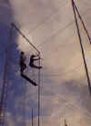

ABC - Simian Summaries (continued)
Chapter Twelve, Bhagavad-gita As It Is, BBT
This Chapter is real simple. Arjuna asks which is better a Devotee or a Logical wise man. Krsna says that both Dudes come to Him, but the wise-guy only after a lot of unnecessary trouble. Then He gives a nice Higher Archy of different levels of guys developing to being devotees. Jaya! After that he talks about the practical qualities of somebody who is becoming or is a Devotee - he doesn’t disturb anybody, he lives a simple life and serves Krsna under the guidance of his guru.
Leaves you wondering what else needs to be said, what Krsna will say in Chapter Thirteen.

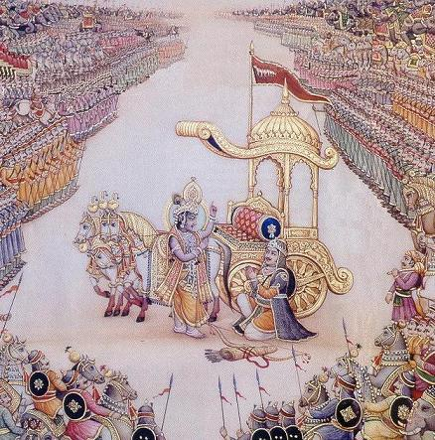

ABC - Simian Summaries (continued)
Chapter Thirteen, Bhagavad-gita As It Is, BBT
Monkey had clamored up the main-mast to his crow’s nest and was read to read Chapter Thirteen, because Piggy said that he couldn’t read Light of the Bhagavata until he finished his BG test, but then again Digital Rat 108 again fell onto his head and ran away as he left another message from Piggy. “Oh my God,” murmured Monkee, “What is it this time. The faster we go forward, the more we go backwards”. It was the second part of Hanumat Swami’s offering for the Felicitations Volume for Dr. Bandyopadhyay.
Well, that was O.K. Dr. Bandyopadhyay was a really nice person. He had taken them on so many adventures. He was not an ordinary person.

EPISTEMOLOGY: Bridging Two Cultures
By Hanumatpresaka Swami
(Huber Hutchin Robinson)

“Yes, Simmias”, replied Socrates, “that is well said: and I may add that first principles, even if they appear certain, should be carefully considered; and when they are satisfactorily ascertained, then, with a sort of hesitating confidence in human reason, you may, I think, follow the course of the argument; and if that be plain and clear, there will be no need for any further enquiry.”
“Phaedo” by Plato,
Translated by Benjamin Jowett ,
http://www.gutenberg.org

Epistemology - That branch of philosophy that deals with knowledge, especially with regard to its methods, validity, and scope, from Greek episteme ‘knowledge’.
Compact Oxford English Dictionary,
http://www.askoxford.com

Trying to write this short paper as a scholarly contribution for a Felicitations volume for the highly esteemed Professor Samaresh Bandyopadhyay, I am reminded that sometimes the two of us have discussed epistemology. It is quite natural since professionally we come from different disciplines. He has been a distinguished member of his academic faculty at Calcutta University and I have been somehow honored with the sannyasa order in our Brahma-madhva-gaudiya sampradaya. Ironically I started by birth in the rational-empiric tradition of science and graduated from the University of California first place in psychology, minor studies in biology and electrical engineering, but have now added the worship of the Hindu divinity, Sri Krsna. The esteemed professor was born into a traditional Hindu family following rituals to worship the Goddess Kali and entered studies at Calcutta University and taking the effort to become trained in the technical, scientific, specialization of numismatics. So this paper is a look at bridging the gap between two cultures at the beginning level of epistemology.

Also in the “Phaedo” Socrates, facing death, draws our attention to the importance of these philosophical efforts. “I reckon,” said Socrates, “that no one who heard me now, not even if he were one of my old enemies, the Comic poets, could accuse me of idle talk about matters in which I have no concern:--If you please, then, we will proceed with the inquiry.” Socrates may die today but all of us have to die one day and therefore these philosophical enquiries should be taken up with utmost sincerity.

First, because space is short, let us simply characterize the scientific epistemology as rational-empiricism. We use direct perception to obtain the first principles as aforementioned by Socrates and then use rational tools such as Piano’s fundamental theorems of Arithmetic, Euclidean Geometry, the Calculus to extend those ideas. But following Socrates we have to suggest that we might be hesitant in extending absolute confidence to human reason.

Reading Sir Karl Popper (1902-1994) and others we find many examples of the limits of this inductive system from science but let us cite one from our own experience, which influenced us to look for truth beyond just the scientific world.

While we were doing our undergraduate studies at the University of California at Berkeley, we took some engineering courses in the Hearst Mining and Engineering building. The learned faculty had taken the effort to have painted on one prominent wall a giant mural of an event that had happened during World War II. The Allies needed to ship war supplies across the Bering Strait from Alaska to Russia. Of course these were very icy waters so metallurgical investigations were made to select an alloy for the ships’ hulls that would have sufficient shear strength to hold up in these temperatures. Tests were made at, let us say, temperature gradients of 5-degrees and the strength of the selected alloy was judged sufficiently strong.

However, when the ships went into service, sometimes, at very specific freezing temperatures, as they bounced up and down, up and down, they would begin to develop fracture lines until in some cases the entire boat would crack in half, and as the mural illustrated the two halves of the ship would be seen floating in different directions as relief ships surrounded them to save the crews and possibly some of the cargo.

Back to the laboratory -- the same stress tests we again repeated but this time at finer temperature gradients and now a marvelous discovery was made. A very narrow temperature range existed in which the entire alloy would become catastrophically weak.

Although we live our lives like everyone, taking advantage of direct perception (Sanskrita - pratyaksa), and then use whatever rational tools are available to us (anumana) to induce truths (aroha pantha), we come to the conclusion that a system of rational empiricism, or scientific knowledge, as we have characterized it, is limited.

ALBERT EINSTEIN
For the scientific method can teach us nothing else beyond how facts are related to, and conditioned by each other. The aspiration toward such objective knowledge belongs to the highest of which man is capable, and you will certainly not suspect me of wishing to belittle the achievements and the heroic efforts of man in this sphere. Yet it is equally clear that knowledge of what is does not open the door directly to knowledge of what should be...
The knowledge of truth as such is wonderful, but it is so little capable of acting as a guide that it cannot prove even the justification and the value of the aspiration toward that very knowledge of truth. Here we face, therefore, the limits of the purely rational conception of our existence.(Ken Wilbur, 1984, pg. 106)

***

In our role as a professor of philosophy we are often asked this question, “How can we know for certain?”

At first we were little bewildered by this question but now we feel we have a clearer conception. Our answer now is that “We cannot know”. If we start with the first principle that there is no God and that we have a completely independent knowledge potency then we can might be justified in asking this question, “How can we know everything?”. On the other hand if we start with the premise that we are small, ignorant beings and that generally speaking our basic knowledge comes from our mother, family, heritage and even intuition, then our first premise might be that yes, we have do have an independent knowledge potency, but it is very small. Yes, we have to make real decisions of independent worth but realizing that it is in a perspective of a broader knowledge that we have received from sources over which we have little God-like control.

In Socrates’ analogy of the cave in Book Seven of the Republic we find the seeds of what we consider a further advance in epistemology over rational-empiricism. Here it is suggested that those who know nothing of a personal existence beyond their shadow selves generated solely by rational-empiricism might be informed that they have a deeper self available to investigate things if they turn from the cave images. Let us call this next level intuitive knowledge. In his essay, "In Defense of Mysticism", Einstein’s friend and protagonist, Sir Arthur Eddington (1882-1944) discusses this.

SIR ARTHUR EDDINGTON
Granted that physical science has limited its scope so as to leave a background which we are at liberty to, or even invited to, fill with a reality of spiritual import, we have yet to face the most difficult criticism from science: "Here", says science, "I have left a domain in which I shall not interfere. I grant that you have some kind of avenue to it through the self-knowledge of consciousness, so that it is not necessarily a domain of pure agnosticism. But how are you going to deal with this domain?
Have you any system of inference from mystic experience comparable to the system by which science develops knowledge of the outside world? I do not insist on you employing my method, which I acknowledge is inapplicable, but you ought to have some defensible method. The alleged basis of experience may possibly be valid, but have I any reason to regard the religious interpretation currently given to it as anything more than muddle-headed romancing?" The question is almost beyond my scope. I can only acknowledge its pertinence. (Wilbur, 1984, pg. 206)

To this challenge we would offer the yoga schools, although certainly not claiming an exclusive position for them in answering his request. For example, before we even fly to these distant Oriental worlds, as we exhaust the limits of our familiar Occidental world, we can consider such available traditions as the theater arts. In the theater we are constantly confronted with questions of what is reality and what is not. The actor and audience must see things that are not there. The actor must respond to people and knowledge that does not exist. Is there a system to investigate this way of "knowing" as required by Sir Arthur?

Yes. “Improvisation for the Theater” by Viola Spolin (1906-1994), now in its third edition, provides an excellent example of this methodology. Professor Spolin dedicates her classic book to Neva Boyd (1876-1963) who was a Sociologist at Northwestern University in 1927. There she was extremely successful in reforming delinquent children and youths from the inner city by a sophisticated theory and practice based upon the game as the basic model of understanding. Her comment was that the game as a way of knowing establishes certain rules, rational-empiric framework, but if we don’t break the rules then we are allowed to use all of our intuitive creative faculties to win the game. The game as a model is a means to include both the scientific and intuitive.

We personally experienced this process. Through an organized, “scientific”, series of games we discovered how to develop intuitive faculties to the extent of releasing and maintaining entire personalities what to speak of manipulating emotional and sensuous reactions. Of course, we recommend the reader to look at the specific book and its tradition, but when we encounter the yoga systems we suggest that we find amongst them an even more profound advance in epistemology.

Are they documented? Is there a publicly available system of knowing? Again, we would answer, “Yes”. Aren’t copies of Patanjali’s ancient yoga sutras available? Are there not active traditions with practicing adepts coming from his texts such as the Hatha and Raja-yoga systems? We practiced such systems but we cannot confirm them with the strong certainty requested by Socrates at death’s door because we have only investigated Patanjali’s astanga-yoga tradition moderately and then we encountered the Bhakti-yoga tradition of Sri Krsna-caitanya and his followers such as Rupa Goswami (1489-1564). Here we have made careful investigation for over 30-years.

Recently a fully annotated translation of Rupa Goswami’s opus magnum, Bhakti-rasamrta-sindhu, has been offered to the academic world by Prof. David Haberman, Chair and Professor of Religious Studies at Indiana University, USA. Therein he comments, "The Bhaktirasamrtasundhu gave definitive form to a religio-aesthetic theory that has shaped many of the cultural productions of northern India from the sixteenth century on, and gave voice to a way of thinking about the religious life that has had a lasting influence into the present day" (Haberman, 2002, Introduction Pg. xxx). The “Bhakti-rasamrta-sindu” is a large work that discusses the process of yoga, bhakti-yoga, in considerable detail. Here we can only hope to inspire the reader to investigate it. Especially, of course, we can recommend commentaries by our own tradition. In Texts 1.4.15-16 Sri Rupa gives an excellent summary of the logic of the process that might satisfy Sir Arthur's demands, "Adau sraddha tatah sadhu-sango 'tha bhajana-kriya... In the begimnning one must have a preliminary desire for self-realization. This will bring one to the stage of trying to associate with persons who are spiritually elevated. In the next stage one becomes initiated by an elevated spiritual master, and under his instructions the neophyte devotee begins the process of devotional service. By execution of devotional service under the guidance of the spiritual master, one becomes free from all material attachments, attains steadiness in self-realization, and acquires a taste for hearing about the Absolute Personality of Godhead, Sri Krsna. This taste leads one further forward to attachment for Krsna consciousness, which is matured in bhava, or preliminary stage of transcendental love of God. Real love for God is called prema, the highest perfectional stage of life." (Bhaktivedanta, 1996, Pg. 234)

To summarize and conclude this brief investigation into epistemology let us say that, not to deny the importance of rational empiricism in orienting ourselves while we are in the cave as victims or helper, still we can find that we also have super-rational-empiric capabilities to investigate reality, which can probably be cultivated by many different traditions, but one tradition which we have rigorously investigated and continue to investigate is the Bhakti-yoga tradition of Srila Rupa Goswami. Based on highly intellectually oriented meditation derived from an enormous corpus of literature, involving music and dance, faculty tutoring, the senses and mind can be fully engaged in the mode of goodness (sattva). At this point it is quite possible to see the self as distinct from either of these two lower instruments. At this stage one goes on acquiring knowledge but with real aim to refine and deepen the motivating principle behind his method of investigation as well as to broaden his ontological and praxiological body. Motivation is considered the basis of acquiring knowledge and therefore whether in science or yoga it must be systematically investigated and purified. If I receive a report that smoking is healthy or dangerous I might be allowed to ask the question of whether or not the investigators enjoyed smoking.

In our dealings with Professor Bandyopadhyay he has several times emphasizes that scientific investigation, in history, should not be confined to simply reading the books of others, but must also include first hand experience of the truth. We warn the reader that only about 75% of what we are presenting is realized by personal austerity. We still make mistakes, but to follow Socrates first citation, we seem to be on the right path.

Correspondingly, in trying to bridge the gap between science and religion for mutual benefit we must offer that science may also have to accept challenges from religion. It must develop its humility a little more to hear the claims of other traditions. Science itself is also a developing epistemology and not without its own fall-downs. In "Betrayers of the Truth", William Broad, New York Times Journalist and Pulitzer Prize winner gives an interesting history of dishonesty in science that includes Sir Isaac Newton, Gregor Mendel, and ironically documenting dishonesty in the modern discipline from the history of one Indian who was able to take himself from birth as the son of a humble Indian railroad worker to being a research scientist in a powerful New York hospital.

In “Forbidden Archeology” Dr. Richard Thompson and Michael Cremo write over 800-pages in critique of the process of knowledge filtering to support the prominent paradigm in archaeology - we are all sons and daughters of apes not the great sages of ancient India. "We are not sociologists, but our approach in some ways resembles that taken by practitioners of the sociology of scientific knowledge (SSK), such as Steve Woolgar, Trevor Ponch, Michael Mulkay, Harry Collin, Bruno Latour, and Michael Lynch.
Each of these scholars has a unique perspective on SSK, but they would all probably agree with the following programmatic statement. Scientists' conclusions do not identically correspond to states and processes of an objective natural reality. Instead, such conclusions reflect the real social processes of scientists as much as, more than, or even rather than what goes on in nature." (Cremo, 1993, Intro.xxiv)

This statement of Dr. Thompson and Mr. Cremo might be a little extreme, but our suggestion is that science must appreciate that truth is not just an impersonal entity and without humility, austerity and mercy it cannot be had in any depth. Let us finish as we began with Socrates.

REPUBLIC, BOOK SEVEN, PLATO
How will they rejoice in passing from darkness to light! How worthless to them will seem the honours and glories of the den! But now imagine further, that they descend into their old habitations;--in that underground dwelling they will not see as well as their fellows, and will not be able to compete with them in the measurement of the shadows on the wall; there will be many jokes about the man who went on a visit to the sun and lost his eyes, and if they find anybody trying to set free and enlighten one of their number, they will put him to death, if they can catch him.

We hope this essay gives some humour, satisfaction and enthusiasm to Professor Bandyopadhay on the occasion of these Felicitations by his many noble admirers, and in general is a successful contribution in the attempt to heal the Cartesian Split which is sometimes described as one of the great errors in the history of Western philosophy. Thank you.

Bibliography
Bhaktivedanta, A. C., "Bhagavad-gita As It Is", Bhaktivedanta Books Trust, 1996

Broad, William J., with Nicholas Wade, "Betrayers of the Truth", Simon and Schuster, 1983

Cremo, Michael A., and Richard L. Thompson, "Forbidden Archelology", Bhaktivedanta Institute, 1993

Haberman, David, "The Bhaktirasamrtasindu of Rupa Goswami", Arts and Motilal Banarsidass Pubishers, Delhi, 2002

Wilbur, Ken, "Quantum Questions", Shambala, 1984

SIMIAN SUMMARIES continued
Chapter 13 BG As It is (T. Brown)
This Chapter is really great. Its like Krsna has finished talking about Bhakti yoga and the Supersoul, and now He’s going back to Sankhya, Cosmology, so that we can be sure to understand that devotional service in terms of the Supersoul is not a material thing. Text-1=Summary of Gita, T-5= anna-maya, prana-maya…, T-6-7=Sankhya, the Elements of the Field, T-8-12=The elements of knowing (1st is hoomility), T-19=SUMMARY!!!, T-20=”It doesn’t matter how we got here”, T-22=Association>Hearing>Liberation>Ananada, …T25 & 26=How some know these things and how we ACTUALLy can know these things!, T-35 SUMMARY OF THE WHOLE CHAPTER!



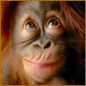

This was too much for Monkey’s tiny brain! He could see that there was so much logic in the way that Krsna and Srila Prabhupada were speaking - First this, then that, if, but, then. He tried to map it all in his mind and remember it, but it was hopeless, at least this time around the Bhagavad Gita.
An Ape’s epistemology:
- Read with the purpose to satisfy the spiritual master, to become capable of carrying on his mission.
- Learn and remember some of the map of the books, but also have a system of reading them again and again.
- You don’t have to remember anything. These books are like a meal. You don’t have to remember that you ate your tortillas and beans to get the effect of the combination when you eat your rice.
Rice, Tortillas and Beans.
Read the books in a progressive order and they will change you. Then when you are reading the Srimad Bhagavatam after the Bhagavad Gita, the BG will automatically be included, just like your practice of the music scales will automatically be included when you play the works of Handel.

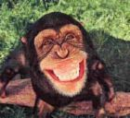

SIMIAN SUMMARIES continued
Chapter 14 BG As It Is (T. Brown)
T1 - Why is this knowledge far superior to all kinds of previous knowledge?! Krsna’s explained pretty intricate stuff before this, no? Here is He just talking about the material world?
Some know, some act and some are helpless: Goodness, passion and ignernce.
T19 – These things are for contemplation, not just reading the BG (karma), nor analyzing it (jñana) but contemplating what you have read and analyzed (dhyana). Then what?

Chapter 15 BG As It Is
T1 - Why would anyone ask, “What about the Vedas at this point??”
“One who wants to get out of this material existence must know this tree throroughly through analytical study.” (jñana)?
“The purpose of the Vedas, as disclosed here by the Lord Himself, is to cut down this reflected tree and attain the real tree of the spiritual world.”
T5 - Again the first principle is Humble.
T20 - A summary: T1-5 describes escaping from weakness of heart and T6-20 describes Purusottama-yoga.

Chapter 16 BG As It Is
T1 – Varna-Ashrama-Dharma qualities. What are those for your ashrama? A sannyasi should not talk with women in a secluded place.
T8 – A VERY strong text about women. The modern world is different than this. We have to change our consciousness or we will be exploited by the Witch!!!

YOU DON’T NEED TO WRITE SUMMARIES. ISN’T BHURIJANA PRABHU’S SUMMARY SUFFICIENT? READ IT FROM TIME TO TIME!

Chapter Five
Docking at the Shore

Monkey went on reading BGAII but before he could finish the last two Chapters and the Quiz Study Notes they began to get very close to the Blue Hill, Nilacala. On the way a strange thing happened, one night when they were sailing Monkey was curled-up dreaming in the Crow’s Nest when he felt DR-16 hopping up and down on his head. He scratched and said, “What is it now?”, and then he saw DR motioning frantically for Monkey to look down.
When he did he saw Piggy and Uncle Gismo motioning softly, “Pirates!”. They had already put out the cabin lights and Monkey quelled the main-mast lantern and shrunk down into the Crow’s Nest until they had passed the evil looking ship that was sailing by them in the other direction.
From inside the cabin Monkey could hear singing:

ALL PATHS LEAD TO GOD
Our path is Whiskey-on-the-Rocks,
With pheasant tongue and candied cocks,
When we’re old there’s blood machines,
Purchase nurses young, white and clean!



As they sailed on by Monkey noticed a sign on the back of their galleon, Buddha, but he didn’t think Lord Buddha would agree with their ideas.

Ώ

The next morning they dropped anchor an inlet on the coast of the Blue Hill, Nilacala. Monkey was all agog. Piggy just said breathlessly, “Niladri!”. Where they landed was a place UG described as Markendeya-sarastata. It was almost on the ocean on the Southern side of the of the Main Temple and occupied by Srila Sarva-bhauma Bhattacary, the greatest scholar of his time.
They stayed on board the SV for some time and Monkey waxed very reflexive:

CHANGE
You wonder what these words can do,
In a week can the world be new?
Yes, I write you read,
And the Read becomes a Deed,
And you pass some Says to a third
And the Word becomes Herd.

Without a shot
Or a bomb,
We all hear just
Of
Sita and Rama

Jaya Radhe! jaya Krsna! jaya Vrndavana,
Sri govinda, gopinatha, madana-mohana

I am just a poor boy whose heard of Their romance,
But though I surely hope to, I never seen Them dance.

MY THINGS
By Tom Brown
I’ve acquired so many things,
But a pad and pen are really jewels and rings.
A book-bag, a blanket, a bucket and beads,
These will satisfy all of your spiritual needs.

And also, how many words do you need to know?
Ice, water, steam, frost, dew, mist, rain, hail snow to make your sentence go??

Radharani refuses to grow.
Radharani refuses to know.
Radharani has captured the Sun,
Because She and Her friends are nothing but fun!

Sack-shirt-shorts-seeds(beads)

But They, Radha-Krsna, will remain forever increasingly unknown,
Unless you abandon your miserly hearth and your home.
Abandon your mind, abandon your socks,
You children & husband, all your bright colored blocks.

For a few days we struggle, grasping for air,
And then our real form emerges, and in Goloka we’re there!

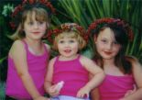

THE CHILDREN SAY
Have not you got more work that’s here?
Teaching those who long to hear?

No! Time to go!

Then diet on fruity-roots,
Push the body out through the anus chutes.
The body returns to the earth,
And the soul departs for the Sun.

Ώ

But now some strict accounting,
How many days to go?
We’ve arrived at the shores of Nilacala,
Bhattacharya’s if you know?
The muscle/bones disintegrate,
The stomachs an easy affair.
Taken down the intestines,
With the fire and the pretty hair.
Ώ

The danger is the adhikari,
Do you have the right to go?
It’s harder to dissolve the karma,
Than to build in Hell with snow!

Three days? The Dhrtarastra-slide (SB 1.13)?
The Houdini Handle Magic Suitcase Hide?

THE CHILDREN SAY
How can you leave the struggle?
Leave it all to us?

THE MONKEY SAYS
You’ll do the same thing when your time comes!
We’ve struggled for over thirty-years,
With the self-same enemies as you.
Now its your turn, to pay your spiritual travel dues!

We have met the enemy, and he is us.

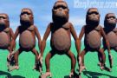
Do you understand the limits in this catastrophe?
Was it Baudeliare who said, from his wise French head,
No one ever finished a poem, he just stopped working on it.
Time to go?

Ώ

Time to go! Nilacala is the door!
Lord Jagannatha is Krsna in Dvaraka hankering for Vraja lore.
Srila Prabhupada is His dog-catcher for us errant souls.

So time to take your medicine (2PM), Krsna-Sri-prasad.
The purpose is to die, not stay here all agog!

THE CHILDREN HEAR
Krsna takes 100% care of girls and sannyasis,
Girls are natural sannyasis,
They have no hope of material success if they don’t marry.
Men have to practice sannyasa, othwise they hurry.

A GIFT OF SRILA PRABHUPADA
Let me tell you what I know of our Guru.
We are a motley crew,
But he is our Captain and guides us,
To come through this battle true.

Srila Prabhupada is tough. No one tougher.
Srila Prabhupada is clever. The best street fighter.
Srila Prabhupada is immortal. His energy never fails.

You can always be with him.
If you read his books,
Do what they say.
Eat what he cooks.

PRASADAM
Take all of your lunch and digest it.
Leave nothing on your plate.
Turn it into your body,
And flow through the iron grate.

TOM’S THINGS
Hanuman is like the 4th or 5th or 7th grammar authority in the universe. He is dressed in shorts and the lightest of upper garments. They paint him with a club but in no Ramayan that we have read does it ever say that he carried a club. He uses his fists, nails, fangs or grabs whatever is at hand, like trees, boulders, mountain tops. So, we don’t have to travel with too many books. Just Upadesamrta, the Nectar of Instruction, and when there is a debate we can just pick up whatever scriptures are at hand.
The library is the scholars workshop,
Abraham Lincoln


TIME POSESSED
Three days are enough to live.
Why hang on to any more?
Adjust your room and furniture
And then head out the door.
You will be surprised how fast things can go!

SIMIAN SUMMARIES continued
Chapter 17 & 18 - BG As It Is (T. Brown)

HYPERLINK "http://rds.yahoo.com/_ylt=A0Je5xWXFIRGbUwBaDyJzbkF;_ylu=X3oDMTBwaGJoOHNtBHBvcwMxBHNlYwNzcgR2dGlkA0kwNjlfOTE-/SIG=1ee4jcri0/EXP=1183147543/**http%3A/images.search.yahoo.com/search/images/view%3Fback=http%253A%252F%252Fimages.search.yahoo.com%252Fsearch%252Fimages%253Fei%253DUTF-8%2526p%253Dwine%2526fr2%253Dtab-web%2526fr%253Dush1-note%26w=337%26h=470%26imgurl=www.cooperagebrew.com.au%252Fimages%252Fwine.jpg%26rurl=http%253A%252F%252Fwww.cooperagebrew.com.au%252Faboutus.htm%26size=94.5kB%26name=wine.jpg%26p=wine%26type=jpeg%26no=1%26tt=3,476,849%26oid=dfebf4bcc730f052%26ei=UTF-8" INCLUDEPICTURE "http://re3.mm-a2.yimg.com/image/2364443352" \* MERGEFORMAT 
The fact was that Monkey felt like a demon, but he didn’t like Bhagavad Gita that much! He liked to study it the way Srila Prabhupada used it in his other books: “In Bhagavad Gita 10.10 we note that the Lord says the same thing”, but it was to big to carry when you had to travel on Sankirtan through the trees (which he often had to do). The Nectar of Instruction he always had with him (we may explain why later). He liked to read it from time to time, to keep it all in proportion, maybe like all 18-chapters with Srila Prabhupada’s purports at it’s birthday, Gita-jayanti, but really he was still trying to perfect his hearing and chanting of the two or three Maha-mantras. After that ??? ? ? ?
He wanted a curriculum that would help him with that.

So, guess we’ll have to ask Srila Prabhupada for a curriculum for animals. Just the ABCs, Animal Bhagavata Curriculum, American Bhagavata Curriculum.

Chapter 17 was Divisions of Faith. At the end of Chapter 17 Krsna said you have to be faithful to scriptures and in Chapter 18 he asked about people who have faith in Australian Whelps and put them on their altars and worship them as Laksmi conches or something else. So in Chapter 17 and 18 Krsna talks about how people have different drinks, foods, charity, austerity based upon the modes of nature that they are in. In Chapter 18 he finishes by saying that you have to give up all these faiths and put your faith in Him.




CHAPTER SIX
They were still in the cove at Sarva bhauma Bhattachary’s house. SBB was away in some other place, so Uncle Gismo was giving some classes on the Bhagavad Gita and some other things. It was pretty good, but Monkey spent a lot of time on the SV. He was using the Morse Code radio he’d discovered. He talked with strange people. One was Partha-sarthi Das. A Hare Krsna in the Iraq conflict 2007 in Warp World Nine:

17 June
Dear Devotees,
Please accept my obeisance's. All glories to Srila Prabhupada!
I am in Iraq now. Here is the address everyone will need if they would like to send a care package.
The address is:

SSG(P) Ari Sonnenberg
G Troop 4-6 Air Cav Squadron
FOB Sykes
APO AE 09351

Again please keep us in your prayers
your servant

***
19 June
Dear Maharaja, Pamo agtSP!!!! Yes sankritan will save us, did 56 soft books today and almost took 3 bullets in the leg..... my life is so funny. Krsna is hving a good time with me. Pray for us
your servant
Partha-sarathi dasa

(Monkey thought – He must really know how to dance really fast!)

***
21 June
Hare Krsna Maharaja, Pamo agtSP!!!!
Thanks for the letter. Yes I followed a full nirjala, almost killed me because of missions but it was worth it. Not eating and drinking water and still doing 18 hour missions is hard. I am finished.

My health is not so good. Was in an explosion followed my small arms, took a bullet. Had a temp. the next day of 103 Blood Pressure of 173/61. Thought I was having cardiac arrest. Good now.... by Krsna's mercy. It's all His hand involved. I am not the body anyhow.. no reason to dwell on these problems or incovienices. The cookies (FROM CAITANYA CARITAMRTA) would be perfect, we are eating very little, fruits and nuts.
I forget my position all the time ha, ha. The goal of life is to always have the Lord's name on your tongue, here that is easy.
Your servant Partha-sarathi dasa

(Monkey - Hare Krsna, What's the solution!? Seems that if the George Bush would get good advice how to promote Sankirtana there, that would be a solution. Moslem Kirtana and Prasadam distribution. Everybody in shorts for a distance of three miles from the perimeter. Best use of a bad bargain.
Hanumatpreska Swami did nirjala until 3PM, 25 letters with advice about abortion, ISKCON politics, Guru tattwa. He was insulted, praised, informed, questioned and then had two more hours of study, nine more rounds, and two hours of classes to give so really felt that it would be damage to the body to go on with the fast -- fruit, nut, milk. Felt Prabhupada was pleased with the decision. We all got different levels of realization and different service, no?
Next there were some stories!!!)

***
My Kuruksetra-Part 1
By Partha-sarathi dasa

In Kuwait now, it is an average of 40°C (104°F)everyday. The heat just drains you. I found the best time to chant is outside at 1AM. I am still keeping to my sadhana and still worshipping my Deities. Krsna is so kind to allow us to serve Him in any situation regardless of where we are. It’s all mind over matter.

Today I met with the Chaplin, in the military we have men of faith in uniform. Their jobs are to help us keep our faith and to inspire us to follow a spiritual tradition. Contrary to what some might think the military is full of spiritual individuals and a great outlet to introduce people to Srila Prabhupada’s books. I was invited by my Chaplin to be involved with our first prayer breakfast while deployed. First he wanted to talk with me and understand my faith. The day came for us to meet and I brought with me about five books. I brought for him, Bhagavad-Gita, Easy Journeys to Other Planets, Life After Life, and assorted small books.
As our discussion progressed he was admitting he didn’t understand the Hare Krsna movement. I smiled and said, “Sir, please take these books, read them and you will understand the meaning of spiritual life”. Reluctantly he took the books and said we would meet again in two days.
In two days we met again, but this time his outlook changed. He said he just opened the Bhagavad-Gita to a random verse and found the following:

“For the soul there is neither birth nor death at any time. He has not come into being, does not come into being, and will not come into being. He is unborn, eternal, ever existing and primeval. He is not slain when the body is slain.”

He said Srila Prabhupada’s purport in this verse touched his heart so much so that he could understand how is the condition soul’s forgetful nature.

The soul is full of knowledge, or full always with consciousness. Therefore, consciousness is the symptom of the soul. Even if one does not find the soul within the heart, where he is situated, one can still understand the presence of the soul simply by the presence of consciousness. Sometimes we do not find the sun in the sky owing to clouds, or for some other reason, but the light of the sun is always there, and we are convinced that it is therefore daytime. As soon as there is a little light in the sky early in the morning, we can understand that the sun is in the sky. Similarly, since there is some consciousness in all bodies? whether man or animal? we can understand the presence of the soul. This consciousness of the soul is, however, different from the consciousness of the Supreme because the supreme consciousness is all-knowledge? Past, present and future. The consciousness of the individual soul is prone to be forgetful. When he is forgetful of his real nature, he obtains education and enlightenment from the superior lessons of Krsna. But Krsna is not like the forgetful soul. If so, Krsna teachings of Bhagavad-Gita would be useless.
Both the Supersoul [Paramatma] and the atomic soul [jivatma] are situated on the same tree of the body within the same heart of the living being, and only one who has become free from all material desires as well as lamentations can, by the grace of the Supreme, understand the glories of the soul." Krsna is the fountainhead of the Supersoul also, as it will be disclosed in the following chapters, and Arjuna is the atomic soul, forgetful of his real nature; therefore he requires to be enlightened by Krsna or by His bona fide representative (the spiritual master).

As he was describing his realizations I saw tears in his eyes and how the spiritual world has opened up for him. How Krsna, as the super soul, and through Srila Prabhupada’s books, woke him up and restored his memory of what it means to be a servant of God. He asked me to give a presentation at the prayer breakfast. I agreed and as I left his office, I turned around and thought maybe I should preach some more, maybe I should explain more of the philosophy to him. As I glanced at him and noticed the way he was lovingly glancing at the cover I smiled and thought how this man truly understands the Bhagavad-Gita.

*Little later*

Spiritual Fitness
Today is the day prior to my moving up north to Iraq. It is also the day of the prayer breakfast that I was invited to speak at. I gave a power point presentation that I titled Spiritual Fitness. The intent of my presentation was to heighten awareness of spiritual life and to introduce soldiers to the basic teaching of Bhagavad-Gita. I decided to use four verses

I am the source of all spiritual and material worlds. Everything emanates from Me. The wise who perfectly know this engage in My devotional service and worship Me with all their hearts. Bg 10.08

The thoughts of My pure devotees dwell in Me, their lives are fully devoted to My service, and they derive great satisfaction and bliss from always enlightening one another and conversing about Me. Bg 10.09

To those who are constantly devoted to serving Me with love, I give the understanding by which they can come to Me. Bg 10.10

To show them special mercy, I, dwelling in their hearts, destroy with the shining lamp of knowledge the darkness born of ignorance. Bg 10.11

Being in the Army physical fitness is the main focus. We teach soldiers’ everyday how to kill, but we never teach them how to die. Being soldiers we live with the fact that every mission might be our last and how the chance of death is everywhere. It is a cold, hard fact that stares at us everyday. Spiritual Fitness is needed everyday. We should encourage and remind each other that God is there with His hand out reaching for us, making opportunities for us to come to Him. I could see as I was explaining these points that it was an intense feeling among the soldiers. They were completely focused.
As I ended my slide show, asked if anyone would have an objection against us chanting the Maha Mantra. To my surprise they agree and I put a slide on the computer with the Maha Mantra so they could sing along. I closed my eyes and prayed to Krsna to allow these men and women feel the power of chanting His name.
As the tempo of the kirtan increased, I saw most had huge smiles on their faces and those who didn’t, were nodding their heads in time to the beat. Finally I finished and put up my final slide, a picture of Krsna holding a chariot wheel and charging after Bhisma. The caption said, “Don’t waste this life. Chant and live a sublime life”.
Everyone then enjoyed their food and I set up my book table and answered some questions. More and more soldiers instead of eating where at the book table taking free books. The Holy Name grabbed onto their hearts. Just as one works muscles to better perform in combat, chanting Krishna’s Name is working the muscles of the brain. This is true fitness… Spiritual Fitness.
The Absolute Truth is Sri Krsna and loving devotion to Sri Krsna exhibited in pure love is achieved through congregational chanting of the Holy Name, which is the essence of all bliss.
CC Adi 1.97

Saturday, 30 June,
9:30PM
It was their last day on the pier at Sarvabhauma Bhattacharya's House. Tommorrow, UG said, they would take their packs and hike overland to the main Temple of Lord Jagannatha in their quest to find Srimati Radharani.

Monkey had stood for his Bhakti Sastri Examination at the ashrama with one of the Bhattacharya's professors as his Proctor. It was pretty fun. He knew most of the answers.

"In the morning they would fan-out and cover as much ground as they could as they headed south, but every evening, after the day's search for Mother Sita, the Monkey's would re-group and discuss the day's activities." Ramayana, kishkinda-khanda.

Before he went for the examination he had joined UG as he gave a two hour Srimad Bhagavatam class in the ashrama. There were about 30 rocket scientists there. UG was trying to explain to them how they could help them to find Srimati Radharani. After the class some of them came up and thanked him for his discourse and said that they would read the Srimad Bhagavatam and the other books more and definitely help in the search.

Jaya!

Monkey also helped to pack some tortillas and cheese for some of them who were going out looking.

Jaya!

But now it was late on the Sriman Vahan and everyone was in their bunks so Monkey read a little bit from the Ramayana as the Sriman rocked gently at it’s moorings and then went to sleep. At 2AM he would wake up and practice his mantras so he could talk to S.R. if they found her.


Good Morning!
There was light in the sky when they set off the next morning all though the sun was not yet up. They each had a small back-pack and walking stick as they climbed up the pathway away from Sarva-bhauma cove. When they got to the top the air was fresh and cool and the smell from the plants would make you want to jump. They sat for a few minutes and watched the sun rise.
“It’s the color of Krsna’s dress”, said Piggy.
“Krsna must be really beautiful”, thought Monkey.

UG rose up and they continued -- UG in the lead and then Piggy and Monkey. Sometimes Monkey would fly ahead by swinging through the trees, but usually he was happy walking in the parade.

About 1PM they got to Nilacala, the Main Temple. Monkey was impressed. It was noon time and most of the shops were already closed, but they found one that had some hot vegetable broth for sale and took their meals. At 4:30PM the gates to the Temple opened and Monkey, Piggy and Uncle Gismo piled in through the two story tall front doors into the Temple.

Uncle Gismo did not remain a common pilgrim for very long. He rapidly introduced himself to one of the Supervisors and was promptly ushered in to see the temple Head Priest, who was a Chinese named Gung Ho.

For two nights they stayed at the Main Temple and UG would be seen walking and gesticulating animatedly while talking with Priest Gung Ho. Monkey availed himself of the extremely pensive environment and would just pace back and forth in the great hall before the enormous forms of Jagannatha, Baladeva and Srimati Subhadra talking to himself.

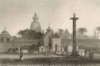

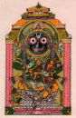

Jagannatha Swami nayana patha gami bhavatu me.
Oh lord of the universe kindly be visible unto me

“Do not think that you are the cause of the results of your actions. Aren’t there so many seen and unseen entities combining to produce the results in this world, so how can we be the cause of them?
Do your job and remember always that Krsna is the dearmost friend of all living beings. After you have gone He will still be there and He will send others to help this living being.
Life is to become absorbed into the bodily conception of life maintained by Krsna of Himself, the darling baby of Mother Yasoda,”

Monkey also visited the Temple library and started to read some books on the history and stuff of Buddhism. There was Theravadin and Mahayana Buddhism. He began to write in his notebook with his pencil.


Another Good Morning
After two nights in the Main temple UG informed them that they would have to travel to another Temple in the forest in the hills high above the main Jagannatha Puri temple. Again they set out at morning but not quite so early.

Monkey liked the walk. It was us rugged mountain trails with streams splashing down by their side. Other hikers greeted them as they progress on the trail. By noon they had reached the Bihari-van temple and then stayed for some time.

An Ideal Institution
In that Temple the monks were up by 2AM for their japa bead prayers. Then at 4:30AM there was mangala-arati, the Medical Miracle. Right after that they had Tulasi-puja and the ladies did the Arati ceremony and lead the Bhajan singing. It was a small temple so they just changed the dress for Radha and Krsna on Tuesday, Thursday and Saturday. On Sunday they expanding Their Lordship’s ornaments with fresh flower garlands and vase flowers, and cooked a big feast offering, so that by Noon when the Sunday Love Feast began the altar and Deities were so beautiful!

Every week at the Sunday Feast they announced the Weekly Puja sponsors. Their donations paid all the expenses for the Temple for that week. Monkey looked at the available dates and then made a donation to sponsor 20% of one week in honor of Hanuman’s mother’s birthday. In reciprocation he would receive a BIG framed picture of the Deitys on the Sunday of the week he was sponsoring and then six DVDs that included art photos of all the different Darshanas of Deities in Their different dresses and ornaments for that week. Also their were some bags made from the remnants of old Diety dresses, Maha-prasadam and copies of a regular lecture series organized by the Deity Department and those special guests.

“Good deal” said the Monkey.

Everybody under the Temple President’s control chanted 16-nice rounds daily, followed the 4-regulative principles strictly and maintained full morning and evening programs, and the Temple had no problems. Sankirtana was on going nicely. Monkey could see how they would be a big help in their task of rescuing Srimati Radharani

Rinky the Rat showed up with another essay by Hanumat Swami:

Bio-graphical Notes
of
His Holiness Bhakti Svarupa Damodara Swami
(Dr. T. D. Singh)

by Hanumatpresaka Swai
(rev. 1 jul ’07)

PREFACE
These are bio-graphical notes about His Holiness Bhakti-svarupa Damodar Swami, Doctor of Philosophy in Chemistry Thoudam Damodara Singh. We present them as an offering to his and our divine preceptor, His Divine Grace Srila A. C. Bhaktivedanta Swami, Prabhupada, who has kindly given the Western world KRSNA: The Supreme Personality of Godhead.

They are written from our perspective as a younger God-brother to Maharaja. Thus they will be different than those written by his students, spiritual children, or so many others. Five blind-men approached the elephant and all had a different experience from their own perspective. Some thought he was like a rope, others like a banana leaf, others like a wall. These are notes from one perspective, please decide for yourself how they are useful.

A BEGINNING
We were waiting for the Mangala-Arati in the Srila Prabhupada Samadhi this last month of Kartika in Vrndavana. Outside some one started to cry and lament. Then Mother Manjari came to me and said, “Have you heard yet? Maharaja has left his body (Bhakti-svarupa Damodara Maharaja)”. Our first reaction was not lamentation and grief. Rather it was, “Oh! At last Maharaja has got some relief”. He had to handle problems with his disciples, God-brothers in ISKCON, preaching to the scientists, terrorists in Manipur, his health. It was Rama-vijaya. There was not even a thought in our mind that Maharaja’s next destination was anything inauspicious. I was just feeling relief for him that at last Krsna was going to give him a little rest.

As the next two days progressed Maharaja’s body was transported from Kolkatta to Vrndavana and placed for eternal rest in the temple he managed in Radha-kunda. Many disciples, friends, came to see him off. For some there was the feeling that Maharaja was gone. But I was feeling that he has not gone. It seemed a little odd to me to feel that he was gone, “He is still available for consultation, he will still inspire anyone who wants to help him in his service to Srila Prabhupada”.

Maharaja’s handsome body arrived in the evening. It was like Krsna coming home to Dvaraka. Devotees lined the path and the steps and balconies. The next day it went to Radha-kunda and we also followed. All this time we were “calm and cool-headed” helping and consulting as we could. After the Samadhi ceremony in Radha-kunda we came back to Vrndavana and that evening there was a memorial assembly in the Kedia land next to the Temple. Lokanatha Maharaja, Gopal-krsna Maharaja, Dhanajaya Prabhu and others spoke. Then as Maharaja’s Sanyasa disciple I was of course asked to also speak and I was contemplating adding a few words to the already dignified glorifications. Then, however, another aspect of my feelings emerged and as I tried to speak I was overwhelmed with intinate memories of our association with Maharaja. We tried to compose ourselves and speak three times. Every-time it was impossible, so finally we had to just pass the microphone back to Lokanatha Maharaja with a gesture of apology. For the rest of the program we just sat there trying to keep ourselves from breaking down with tears and lamentation. Maharaja was like that. He inspired different feelings at different times, and our hope is that he will continue to inspire them as we try to serve Srila Prabhupada in his association.

Chapter Seven
19 July. The Days in the Mountains finished and they headed by Flying Cloud to another Temple on the Sea Coast where the form of Jagannatha known as Nila-madhva was worshipped.

The Sriman Vahan was waiting in the Harbour. “How did he get here,” asked Monkey? “He’s very accommodating,” replied Piggy.

Monkey went on board again. He thought that he would never leave. This was his home, at least until they found Srimati Radharani. While traveling they met so many people, but they were not concerned to find Srimati Radharani and help Her. It made Monkey very sad: Oh, well, best to travel alone, move very fast, look for Her, reassure Her, and return with Her address to Krsna.

While they waited for UG to talk with the Priests at the Nila-madhava Temple, Piggy cleaned the SV. It had been some time and things were out of Whack. Monkey went to the Never Ending Bookshelf and looked into it with great perspective. Yes, the Light of the Bhagavata was there. He slowly tried to pull it out. His Bhagavad Gita studies were done. His work for Piggy’s Science and Religion Congress in Buenos Aires was up to date. His Hindi studies were up to date.

Slowly, slowly he pulled on the LOB and …. and … and … it came out of the Shelf. Here was the means of talking to Srimati Radharani. Here was the means of finding Her. She was hidden in the hearts of cultured, intellectual people, and learning this book one could learn to speak their language and enter into their hearts.

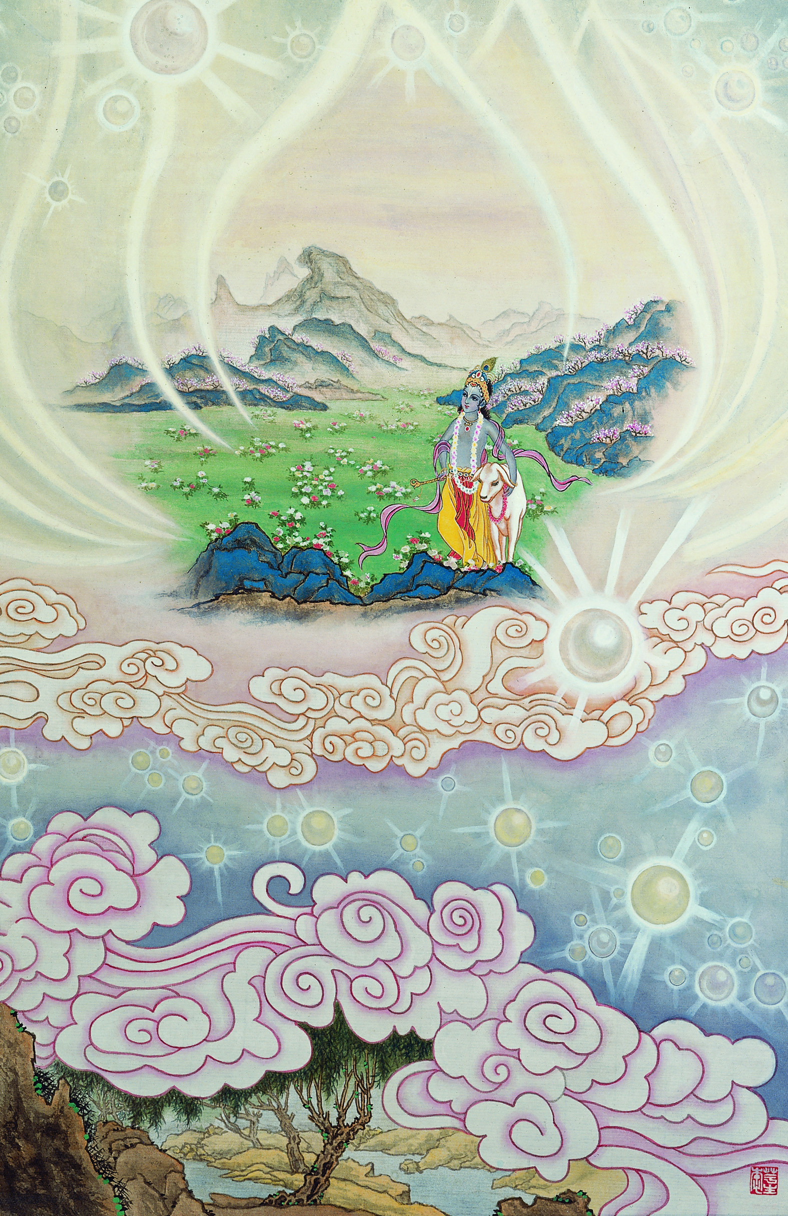

Light of the Bhagavata
Preface
This is how the book was made,
For whom he wrote, for whom he plaid.

The people enter an assembly hall.
They’ve come to hear how to make Spirits tall.

Cultivation of the Human Spirit
China/Japan 1961
The Sensitive Brush of Madam Su Liu Yung

Overview
Texts 1-21 Describe the Coming of the Rain,
After the torment of the Sun.
Rainy Season

Then 22-26 How Sri Krsna comes out to play,
And we return after having been too long away.
Ontology

Then to Forty-eight,
Which is the end,
You’ll find lessons on Society,
And how to be it’s Friend.
Daivi Varna-ashrama Dharma

That’s all, so many more Things to Learn.
You must Talk to People within the Hall.
Read the Book and Take a Look.
Collect your Notes so you can Cook!
Ready for Dinner.

Saturday 21st July.
Monkey was walking around the:

Hare Krsna
Temple of the Rain and Mist
By the Sea

When he saw some people making big back-drops for a drama. They were dressed like workmen and he asked them what they were doing. “Oh, it’s very interesting”, they said, “We are making the backdrops for a drama for Janmastami”.
Of course, Monkey asked, “What is Janmastami?”
“You, don’t know”, said the workmen?
“No” , said Monkey, “I am an ignorant fellow and new to your ways and beliefs”.
“Oh, yes”, said one of the bigger, workmen, with a mustache, looking at him thoughtfully, “Sit down and I’ll tell”.
“Thank you”, said Monkey, “but do you also have a pint of boiling Milk and a Banana I could take?”
“Of course,” said the Workman-Foreman, “Phillip, trot on over to the Prasadam Hall and get some hot milk and a banana for this fellow”.
It went right to Monkey’s brains and while he was listening to the story of Janmastami he drifted of into sleep, and while he was sleeping he dreamed.

He dreamed he was in a big wresting arena. There were all kinds of people there: Rich folk, artisans, and nobles. The evil King Kamsa had arranged a wrestling match for sport, but everyone knew that it was a trick to get Krsna and Balarama to come to Mathura so that Kamsa could have the stone-like wrestlers kill Them.

Ooof! Grawnk!!!! Brack%$! Biffff! Krsna and Balarama fought with Canura and Mustika. They twisted, grabbed, popped and pulled. Actually Kamsa was a demon named Kalanemi from the Celestial World who had taken birth as a human to get control of the Earth. He and his friends had all taken birth as Kings, and just liked things like whiskey, cigars and parties. Uuuugh!

The Demi-gods had prayed to Krsna and He had agreed to incarnate and fight with Kamsa. In the beginning He had grown up in Vrndavana and thought that He was the Son of Nanda Maharaja and Srimati Radharani and all the cowherd boys and girls were His friends and they would live there forever.
But one day Akrura came and told the whole story. Krsna was actually the son of Vasudeva and Devaki and now He had to go and fight with the wrestlers and kill the evil Kamsa.

Well he did that.

Ooof! Grawnk!!!! Brack%$! Biffff!

And everyone became very happy. His father and mother were freed. He went to school at Sandipani Muni’s ashrama. He married beautiful Srimati Rukmini and He killed all the other demon friends of Kamsa. But he was always remembering Vrndavana and His friends, and cows and Mother and Father there and He wanted very much to go back to Vrndavana and stay there forever.
Sri Krsna Janmastami Ki Jai!

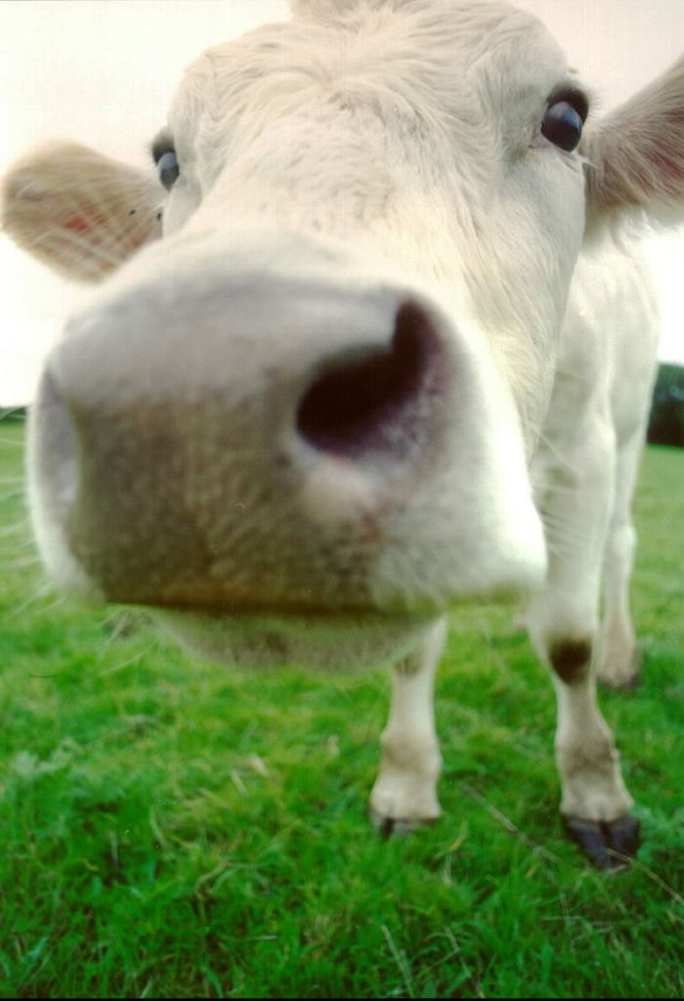

Wednesday 25st July

Srila Prabhupada’s Grace
Monkey doesn’t Monkey around.
Even when he’s half asleep,
His intelligence is still sound.

Sitting the Crow’s Nest on the boat,
His pen working taking note.

Light of the Bhagavata
ASA Notes
By Tom Brown
(rev. 29 July 2007)
A lot more work needed.

(See also SB Chapter 20, Canto 10, and Krsna Book.)
END OF SUMMER
1 – sky, clouds, lightning = Ontology, ABAT, Vedanta
2 – scorching summer > rain = Purport focuses on Distribution. ¶ = ½ source (ie taxes are good). Gvt should not allow rainfall on rocks. Gvt = 1) Demonocrary, 2) Monarchy, 3) Deva … All three require good citizens and good adm. 1) Deva adm is good but people bad, no yajna for Visnu, 2) Ksatriya and citizens taught, 3) Adm should use tax to educate the people.
3 – clouds bring rain = god is merciful… substance of their life = because … See kind is God by His system… ¶Therefore – must be a God… ¶Why does God wait so long to give relief? (See also Text 2).

RAINY SEASON
List:
Bad –Seasonal Grenery, Glow Worms
Good –
Reformable – Frogs

4 – after rain green = material temporary prosperity
5 – glow worms = Dark evening of Rainey Season = Kali Yuga, No guide from Moon (SB) or Stars (BG) or their Rays (Acharyas). Glow worms (Bogus Acharyas) are envious (“No God”).
6 – frogs in caves = Interfaith co-operation. Religion as Institution. Make Common Platform = There is a Supreme will w/o no happiness.

(29 July ’06)
7 – flooding rivers = introspective x extravagant excess
8 – butterflys flowers = more 4 & 7
9 – gloomy capitalist = VAD farmer x capitalist, communism
10 – fish frogs stout from water = ISKCON b’caris good use. X 4,7,8
11 – rivers, ocean agitated = sex agitation for yogis w/ no guru
12 - rain pounds mountains = daya bhak, krsna’s mercy
13 – rain grass cover roads = brahmanas with no sadhana
14 – lusty lightening flash = unchaste wife
15 – rainbow = avatars no material contact
16 – moon moves in clouds = ontology we aren’t the body
17 – peacocks dance = VAD grhastha happy receive sannyasi
18 – fat plants = kama lata bija more 4, 7, 8, x10
19 – punctured cranes = def. of VAD, details grhastha (politicians)
20 – dykes break = epistemology upstarts attack Vedas
21 – clouds distribute = x 3, brahmanas inspire kstrya & vaisya

AUTUMN
Krsna Appears in Vrndavana
22 – black-berrys dates = avatar show heaven, L C & 6-gos expand
23 – milk bags overflow = more 22 & our love will flow
24 – blossoms weep = 23 and flow
25 – taste fruits = ACBAT Jiva & God
26 – boys share food = patram, puspam phalam
27 – cows cud = value of cows
28 – vnrdvn attracts all = material nature picture of spiritual world. Yukta vairgya

Symptoms
29 – lakes clear = mukti no clouds
30 – lakes clear & lotuses = yoga ladder
31 – four symptoms of autumn = 4 VAD & w/o daivi all = burden!
32 – white clouds = VAD def sannyasi
33 – waterfalls yes/no = 2 types of K katha, bhagavata sapta
34 – lakes dry fish die = VAD grhamedhi (Politicians) x 19
35 – lakes dry = more 34 VAD to many kids
36 – mud drys = disp false ego, like dry coconut
37 – sea calm = VAD to vanaprastha (polticians)
38 – dykes = VAD conserve energy for yoga x 20
39 – contrast day and night = material life x spiritual life (gopis)
40 – clear sky bright stars = can see vedanta = BG 15.15-18
41 – moon stars x krsna yadus = avatara 4.9, 9.11
42 – mild wind nice and pain = sambhoga & viraha bhakti
43 – sex impulse, stags = NOI 3 then right time result WILL come
44 – kumuda x lotus = VAD Ksatriya x rogues democracy
45 – anna-kuta festival = prasadam, god sends food, say thanks
46 – after rain can go out = after death get the result.
47 – cosmos = ACBAT moon planet etc.
48 – moon etc = more 47, beyond celestial

29 July Monday
They had arrived at a place in the Mountains. It was sunny again. UG told them to meet him in Hugh’s Town, so Monkey took charge of rowing the boat. But now the SV would actually only do what it thought UG would want it to do, so most of the time Monkey could sit up in the Crow’s Nest with Piggy and work on his LOB Notes etc.

